Prove it! Toolkit
2. Questionnaire Instructions for administering the survey

Contents
Introduction 1
Using the Prove It! Toolkit survey 2
The Toolkit questionnaire 3
Measuring effects on project participants and the wider community 7
Designing additional questions 9

Introduction
Ideally, an evaluation of a project should include an investigation of the effects of the activities on a wider sample of individuals than can be included in a workshop or focus group. To this end, the Prove It! Toolkit includes basic materials to help you, as project manager, to design and administer a survey that looks at some important aspects of the change that your project might have brought about, particular in relation to effects on social capital and quality of life. This part of the Toolkit consists of an outline for a simple survey questionnaire, (along with a series of files to assist in the design, administration and data analysis) that can be used with project participants and members of the wider community.
Surveys can be administered through self-completion or by interview. A self-completed survey is one where the respondent fills in the questionnaire by themselves using pen and paper, by email or even on the Web. For an interview, the questions are asked in person (face-to-face) or by telephone. Surveys are useful when administered properly: they are able to provide numerical data (sometimes referred to as ‘quantitative data’) and offer the advantage that they can be repeated at different times to show trends.
Before deciding that a survey is the most appropriate method for gathering data, it is important also to consider some of the alternatives that might be more appropriate at this stage of the evaluation. In addition to the discussion groups used for the Project Storyboard and Project Reflection Workshop elements of the Prove It! Toolkit you might also consider using detailed research interviews, community consultation events or research diaries where people write down their feelings, behaviours and activities over a set timeframe. Most of these methods provide verbal or descriptive information (sometimes referred to as ‘qualitative data’) and can often be used alongside quantitative data to help explore findings in more detail.
The rest of this part of the Prove It! Toolkit provides guidance on how to use the readymade questionnaire files. It includes instructions for how to work with the Excel files: Questionnaires Template and Data Entry and Additional Questions Templates. These files have been designed as a basic data collection tool for administering and collecting survey data. We also include some additional things to think about when designing and administering surveys.

Using the Prove It! Toolkit survey
To make the survey in the Prove It! Toolkit as simple to administer as possible we have chosen a Core List of the most powerful indicators of a project’s impact on social capital and quality of life. For each indicator there are between one and three simple questions to be asked of project participants and members of non-project-participating members of the wider community.
This core list of suggested indicators relates to the potential effects of a project on:
- Frequency of use of the new space or facility
- Attractiveness of the neighbourhood
- Levels of community safety
- People’s inclusion, involvement and trust in local decision-making processes
- People’s networks and contacts:
- for achieving change
- for feeling connected to a community
- in case of a need for help
To these, you, as project manager, may add further indicators that will be specific to your project. In addition there are some readymade demographic questions that can help you to establish and report which specific groups of people have been involved or affected by your project.
The current wording and layout of the questions represents how a simple social capital survey could be conducted. We acknowledge that although many overriding aims are similar, every project is different and we have set it up in a way that allows the individual wording of each question to be altered to suit local circumstance.
In addition, this MS Excel file contains linked spreadsheets for entering data collected both before and after a project has been completed. These in turn automatically update a series of graphs so that the data can be viewed and compared easily for a simple analysis. If you choose to add indicators to the core list, and wish to use them in a questionnaire, we have provided a separate folder that contains a number of smaller Excel files, each one representing a blank question template, along with a corresponding data entry and graph sheet that can be used in conjunction with the main questionnaire. Unless you are comfortable enough with MS Excel to design your own questionnaires, we suggest you produce and print off separately any additional questions you design for your evaluation with the help of the instructions provided in this folder.

The Toolkit questionnaire
The MS Excel documents Questionnaires Template and Data Entry and the files contained in the folder Additional Questions Templates provide a template for designing a questionnaire based on the eight core indicators chosen from Prove It! The document is made up of six linked spreadsheets. We recommend that you open the Excel file and review each sheet accompanied by the following notes:
- Core Indicators Questionnaire – this shows the text for the questionnaire based on a core set of indicators laid out ready to print off and photocopy. All that is needed is to make sure that the wording for each question relates to your project. (E.g. Where it says ‘(Project Area)’ you will want to type in the name that best describes the neighbourhood in which you are working.

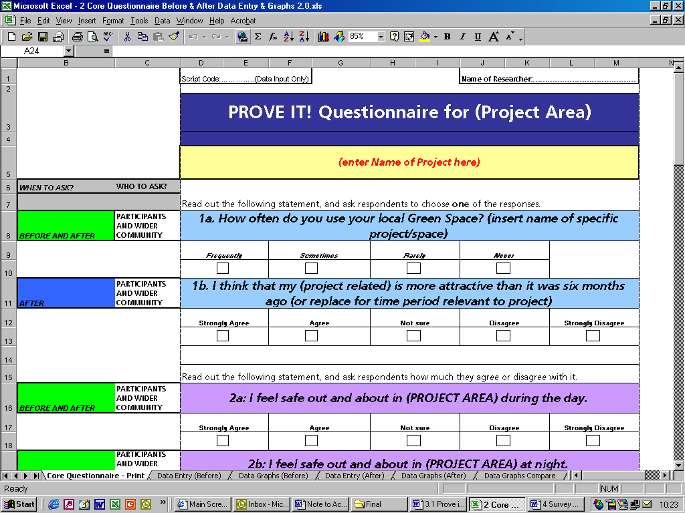
- Core Data Entry – this represents a prepared spreadsheet on which you can enter the responses from completed questionnaires. Where a respondent has chosen a particular answer, this should be recorded by entering a ‘1’ in the appropriate cell in the spreadsheet. The bottom three rows add these up and give you a percentage breakdown for each question.
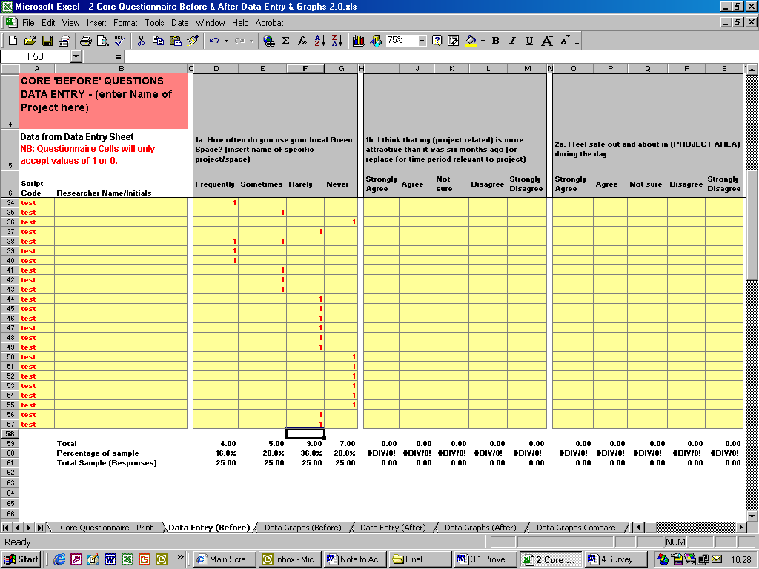
- Core Data Graphs – this spreadsheet is linked to the previous one, and automatically turns the recorded responses into graphs that can either be printed out as a set or pasted individually into an MS Word document report.
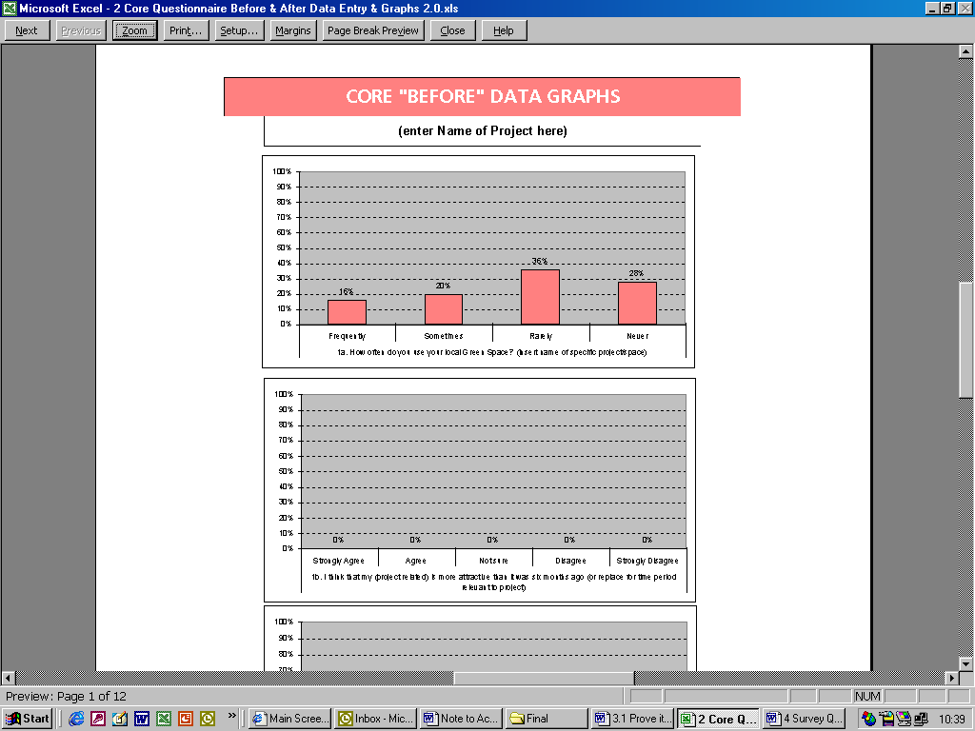

- Core ‘After’ Questions Data Entry – this is similar to (2) above. It is another prepared spreadsheet on which you can enter the responses obtained from surveys carried out after the completion of the project.
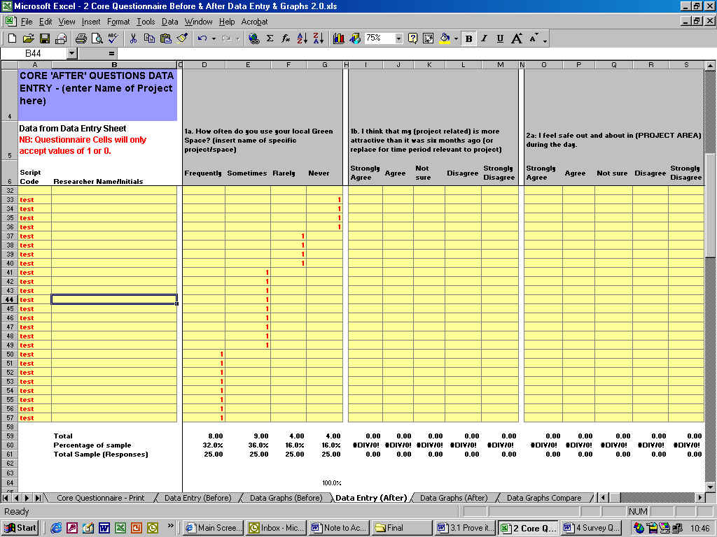
- Core ‘After’ Data Graphs – a spreadsheet similar to 3 that automatically turns the previous spreadsheet data into graphs that can either be printed out as a set or pasted individually into an MS Word document report. 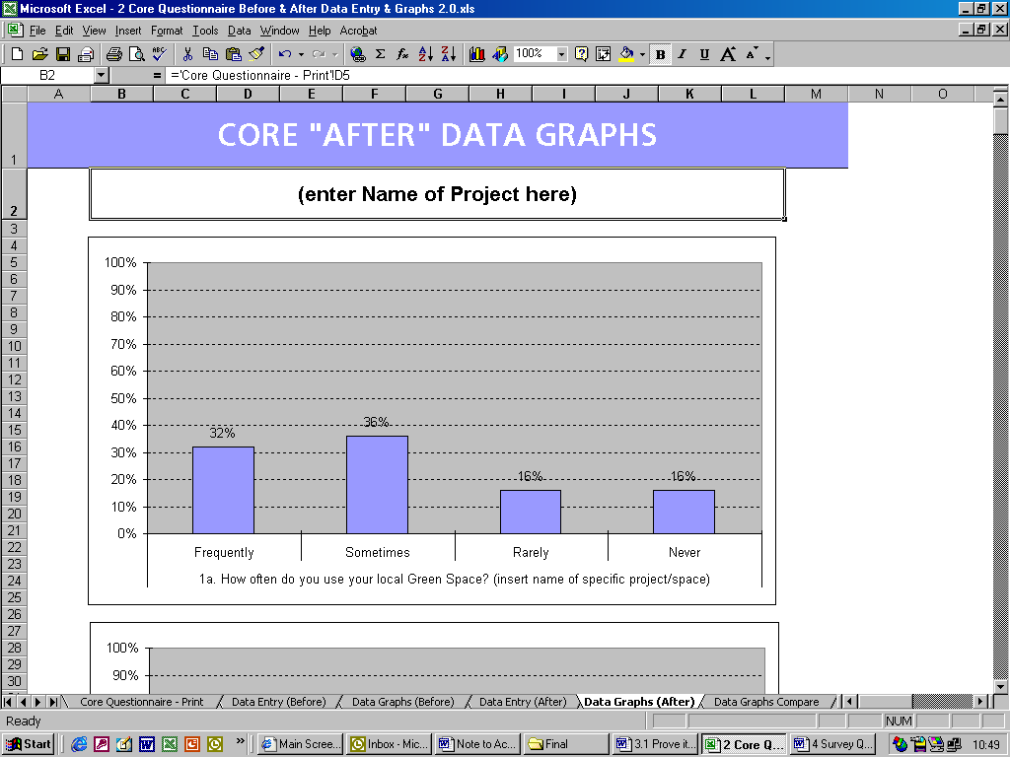

- Core ‘Changes’ Data Graphs Comparison – this spreadsheet provides a bar graph that compares before and after responses to each question in the Core Questionnaire in two contrasting colours. Like spreadsheets 3 and 5, this can be printed out or cut and pasted into MSWord documents for a final report.
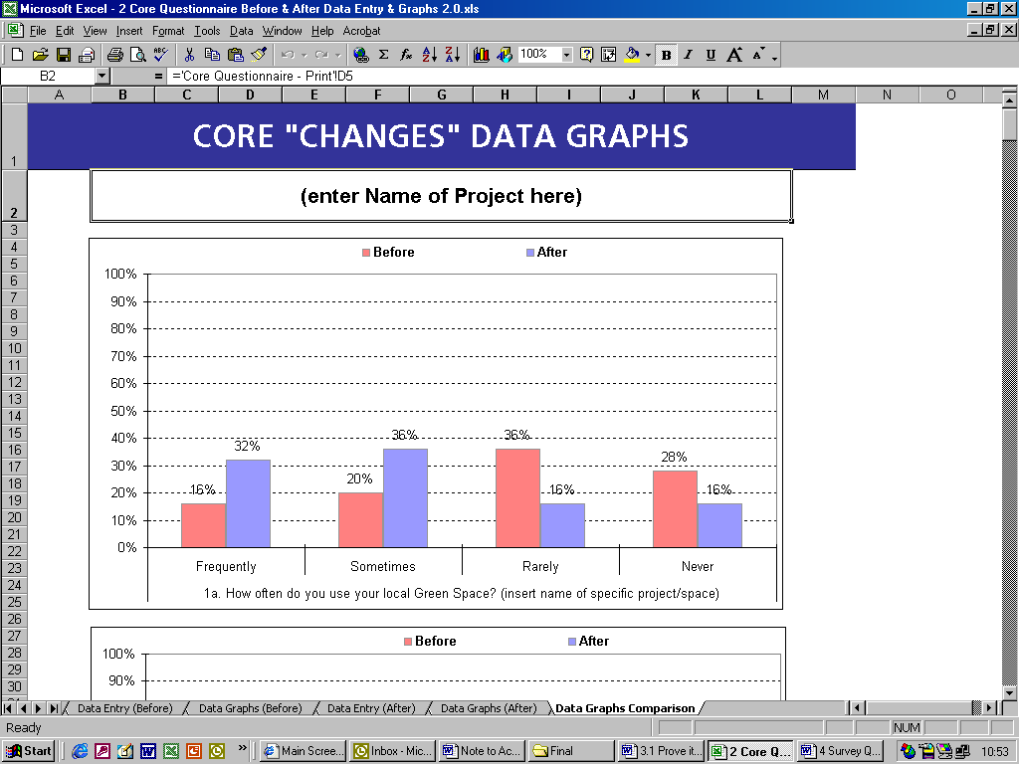

We recommend that to keep the process as simple as possible you use the questionnaire format provided on the first spreadsheet. (See 1 above)
As you read it through to finalise the wording you will notice that you will have to fill in bits that are specific to your project. As you do so, the corresponding boxes in the Before Data Entry (Sheet 2) and the Before Data Graphs (spreadsheet 3) along with corresponding boxes in After Data Entry (spreadsheets 4–6) will be automatically updated, too.
At the top of the Questionnaire (spreadsheet 1) there are spaces for the researcher’s name/initials and for a unique Script Code Number. When the data is being entered onto spreadsheets 2 and 5, whoever is typing it in needs to generate a combination of letters and numbers that is unique to that script. (E.g. ‘initials of the interviewer + a number’) This is important because as part of checking the results you may need to trace responses back to a particular script. Once you are happy with the wording for the questionnaire, you can print it out onto A4 paper and photocopy it for use by you or your researchers.
The Toolkit also includes a folder called Additional Question Templates, that contains a number of separate MS Excel documents providing blank question templates in different formats, with corresponding Before and After Data and Graph spreadsheets. These have been included and arranged so that you can design you own questions and add them to the Core Questionnaire described earlier. The additional questions can then be reproduced separately, and a paper copy added to the main questionnaire if required. The data collected from these questions must then be entered on the Additional Data Entry spreadsheets in these documents as this will help produce the graphs for comparison.
An MSWord document (Additional Question Template Instructions) has been included to guide you through this process.

Measuring effects on project participants and the wider community
Note that some questions are specifically designed for project participants, whereas others are for the members of the wider community and project participants alike. The following section describes how the questionnaire should be administered to each group.
Using the questionnaire with project participants
The aim here is to get questionnaire responses from 100 per cent of project participants involved through the lifetime of the project to find out how your project has affected them.
What to do
- We recommend that the following instructions be added to the beginning of the surveys you administer to project participants:

‘(Our organisation_________) is conducting a survey about how people who have participated in _____________________________feel about this community and the project. The survey won’t take more than _____ minutes. The results will be used to measure if (_____________name of project) makes our community a better place to live.
Please circle your answer to the following questions. Remember there are no right or wrong answers.’

- To reduce the workload, project participants could complete the questionnaires on their own (i.e., not carried out by interview) except where there is a concern about literacy. If this is preferred some minor adjustments to the wording will need to be made to the way the questions are phrased.
- If interviews are needed then the same interviewer should interview all of the participants.
- As project manager, you should not be the one to interview participants as they may find it difficult to speak freely.
- As the interviewer reads out the questions and potential answers, he/she must show respondents a card with a scale showing all the potential answers for them to refer to (e.g., Agree strongly, Agree, Disagree etc.) to avoid confusion.
- When reading out a particular question, it is important to read it just as it is written in the questionnaire.
- Finally, keep track of those who move from the area or who end their involvement in the project. Ideally the questionnaire will be completed at the beginning and the end of the project.
Using the questionnaire with the wider community
The aim here is to get questionnaire responses from members of the wider community.
What to do
- We recommend that you add the following instructions to the beginning of the surveys you administer to members of the wider community:
Before starting the survey, please read out the following:

‘Hello, my name is __________________________and I’m conducting a survey about how people in ______________________________feel about our community and our new (project/park/greenspace ___________________________). This survey is being conducted by (organisation_______________) and it won’t take more than _____ minutes. The results will be used to measure if (name of project_______________) makes our community a better place to live. There are no right or wrong answers.
Are you happy to participate? YES/NO. Thank you very much.’ Don’t persist if people say no.

- Some of the questions contain up to five potential answers. It is recommended you prepare CARDS where the potential answers are written down in large fonts. When you ask the question, you should both read out and show the card to the respondent with the potential answers.
- When reading out a particular question, it is important to read it just as it is written in the questionnaire.
- You could conduct a rigorous (scientific) survey by selecting a random sample of respondents. This probability sample is one in which each person in the population has an equal, or at least known chance of being selected. You should follow this method if you want to extend the results from a few responses to the entire community. It is also useful to follow this method so that you can get different perspectives. If you simply get feedback from those who attend open days there may be a bias towards those who know and like the project.
- Non-random samples are easier to administer. You could not derive, however, results for the entire community from a non-random sample. If you want to conduct a non-random sample, all you could say in your final report is something like: ‘From those who responded, 10 per cent feel safe in their community.’

Designing additional questions
Here are some points to think about when finalising the wording of your questions, particularly if you are adding extra questions to the basic Prove It! Toolkit survey.
- Overload: Don’t ask two questions in one. This is known as overloading. An example is ‘I feel I could help change attitudes and improve things around here’. This can be a little problematic, e.g., if people feel that they can change attitudes but not improve things or vice versa.
- Scale: Often a five-point scale is used, but it needn’t be so. Sometimes, as in the case of ‘do you know who to contact in the local area…’ three points might be better, e.g., ‘yes’, ‘no’ and ‘don’t know’.
- Style: There are different ways of eliciting responses: e.g., scenario-based questions – would you go to the shops for your immediate next-door neighbour(s); or experienced-based – have you in the last six months been to the shops for your immediate next-door neighbour(s). Experience or action-based data may be preferable. The latter would be preferred if it is thought that there will be a discrepancy between what people say they do and what they actually do, e.g., come to the assistance of a neighbour.
- Before and after: If you are doing a before and after comparison, then the wording of your questions needs to be exactly the same AND the sequence in which the questions are asked needs to be identical.
Statements like ‘I feel safe in this community’ are good for baseline comparisons if a project’s impact is to be viewed over time. But if this statement is only to be used once, it in itself doesn’t necessarily tell us what impact the project has directly had on local safety.
Attributing outcomes to specific projects is always challenging as none of this kind of work happens in a vacuum; there are always other factors involved in contributing to pride, well-being and quality of life. One way around this would be to ask people specifically: ‘As a result of {this project} do you feel safer in this area?’
- Trying it out: It is important to try out your questionnaire on one or two colleagues or project participants before you make the full survey. Do this with a view to making changes to the layout and wording depending on the responses you receive.
- Avoiding bias: Bias is introduced when the results of responses to a survey may be influenced unduly. For example, it may not be helpful to have a project officer interview local people about their project. If you are comparing across different projects or times, or aggregating results, then consistency is key. Perhaps only use local people to interview or only use project officers.
Either way the interviewers need to be tightly briefed so that questions are being asked in a uniform way. When comparison is less of an issue, then consistency becomes less important, too. This needn’t mean that you can’t use creative methods of collecting data, like a group show of hands. But beware of bias and make a careful note of findings. For example, if a show of hands might have an element of peer pressure, can people be asked to close their eyes before the show of hands happens?
And finally…
Here are some general points that should be remembered when using the Prove It! Toolkit questionnaire.
- How many people should be involved? What groups of people should you approach? (Sample)
- What else will you need to know alongside the data? For example: age, gender, ethnicity, marital status, physical health or residential postcode of respondents? (Demographics)
- Are there any language barriers in terms of literacy or non-English speakers? Is there a need to re-phrase some indicators/questions if using them with children? (Language)
- When should data be collected? Should it be during the day or in the evening? Weekday or weekend? And in relation to key local events/activities which may affect people’s responses (positively or negatively).(Timing)
- Who will do the measuring? The community group leader or the project officer? Local residents who are trained/supported, or a research organisation who is commissioned to do the work?
- Are there costs involved in the data collection process? (e.g., In order to pay for external research support, community researchers, or to provide incentives for respondents.)

For more information on using random or non-random samples visit the following weblink: http://www.custominsight.com/articles/random-sampling.asp nef consulting can provide some guidance on helping you decide whether you want to do random sampling and provide suggestions on how to administer it. www.nef-consulting.co.uk

